Experiment - 08
Configuring User Management and Role-Based Access Control (RBAC)
SAI PRANAV B.V.
241401088 CSBS
AIM
To configure user management and Role-Based Access Control (RBAC) in the Patient Appointment & Scheduling Management application in Zoho Creator, so that different users such as administrators, receptionists, doctors, and patients have appropriate access to application features and appointment records.
OBJECTIVE
To configure the following in the application:
- User roles and hierarchy.
- Permission profiles for different staff members.
- Data-sharing rules between roles.
- Restricted portal permissions for patients.
- Localization settings.
- User and role access verification.
USE CASE
The application manages patient appointment bookings and scheduling. Different users require different levels of access:
- Admin/CEO: Has administrative control over the application.
- Receptionist: Manages patient appointment bookings and scheduling.
- Doctor: Views appointment information relevant to medical staff.
- Patient: Uses the portal to submit appointments and view permitted appointment information.
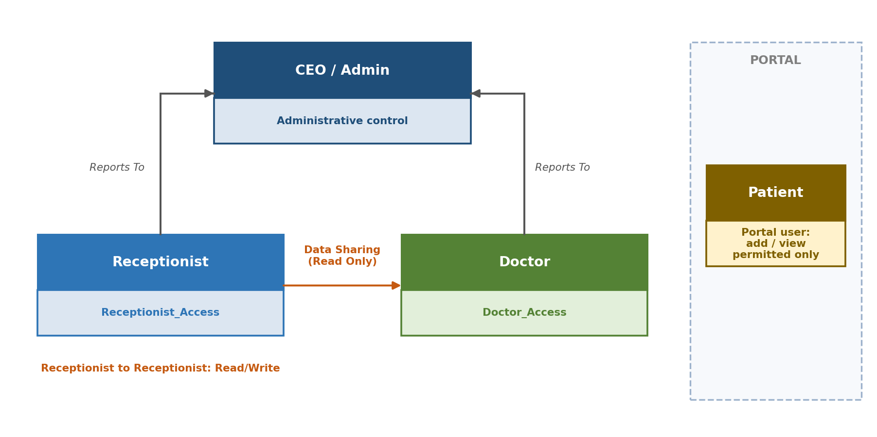
Fig 1. Role hierarchy, data sharing, and portal access for the appointment application
PROCEDURE
Step 1: Configure User Roles
1. Open the Patient Appointment & Scheduling Management application.
2. Navigate to Settings → Permissions → User Permissions → Roles.
3. Create the roles listed in the table below.
Role | Reports To | Description
Receptionist | CEO/Admin | Manages patient appointment bookings and scheduling.
Doctor | CEO/Admin | Reviews and manages appointment information relevant to medical staff.
4. Keep peer data sharing disabled unless it is specifically required.
5. Save the roles.
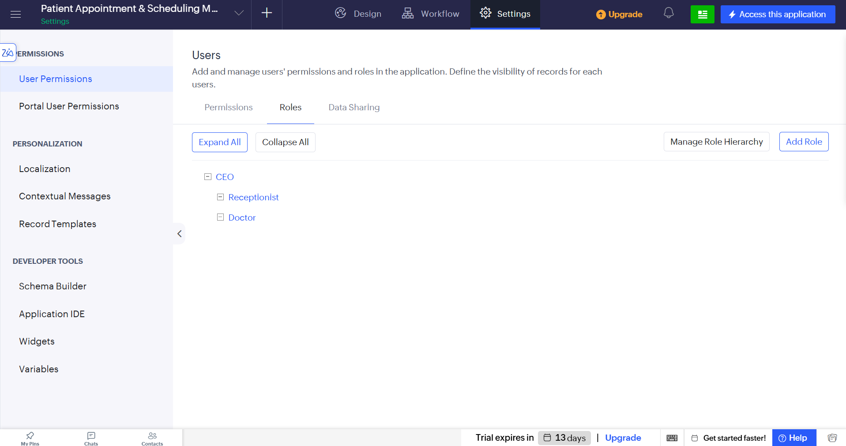
Screenshot 1 — Roles page showing the Receptionist and Doctor roles

Step 2: Configure Permission Profiles
1. Navigate to Settings → Permissions → User Permissions → Permissions.
2. Create a permission profile named Receptionist_Access.
3. Provide the Receptionist with access to Appointment_Booking_Form (View, Add, and Edit) and the appointment booking report (View and Edit where applicable).
4. Create another permission profile named Doctor_Access.
5. Provide the Doctor with access to Appointment_Booking_Form (View) and the appointment booking report (View).
6. Save both permission profiles.
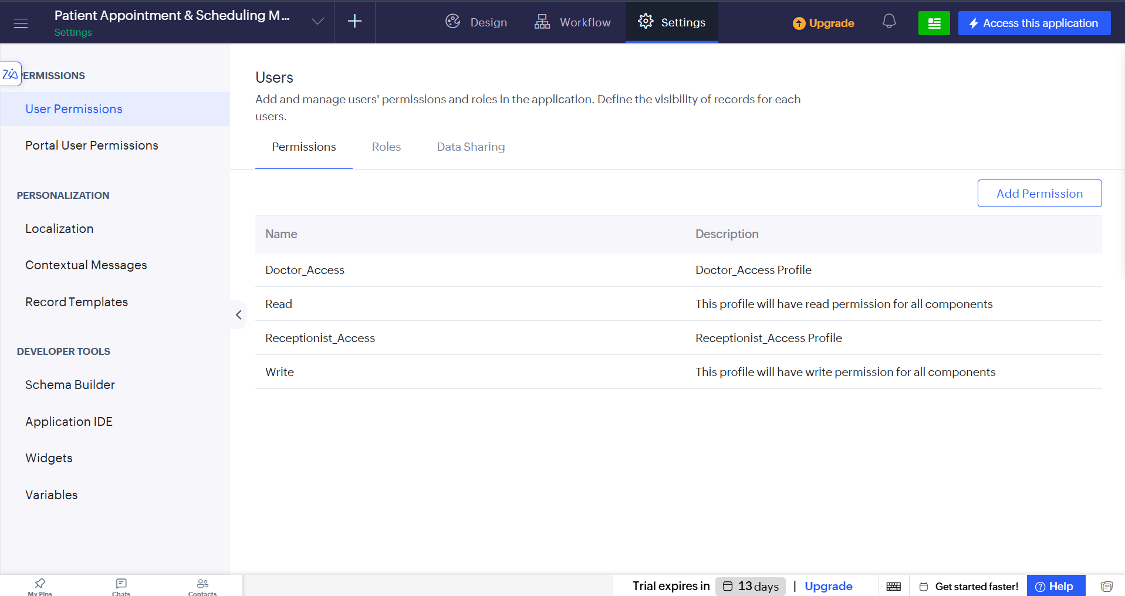
Screenshot 2 — Permission profiles page showing Receptionist_Access and Doctor_Access

Step 3: Configure Data Sharing
1. Navigate to Settings → Permissions → User Permissions → Data Sharing.
2. Create sharing rules for Appointment_Booking_Form as listed in the table below.
3. Save the sharing rules.
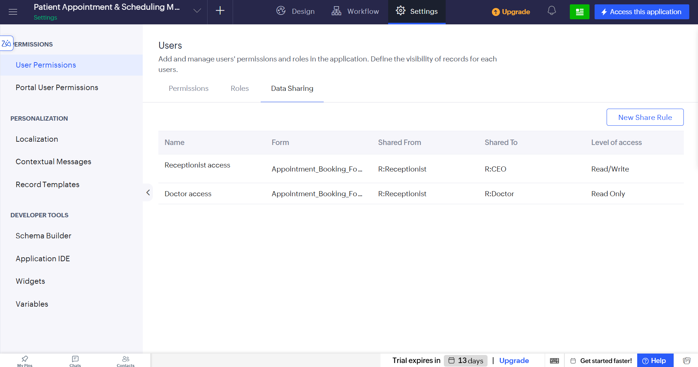
Screenshot 3 — Data Sharing page showing the configured sharing rules

Step 4: Configure Portal User Permissions
1. Navigate to Settings → Permissions → User Permissions → Portal User Permissions.
2. Use the existing customer/patient portal permission profile if available.
3. Allow patients to add appointment-related information and to view permitted appointment information where available.
4. Do not provide patients with unrestricted access to other patients' records.
5. Do not provide patients with internal reports, application settings, or developer access.
6. Save the portal permission configuration.
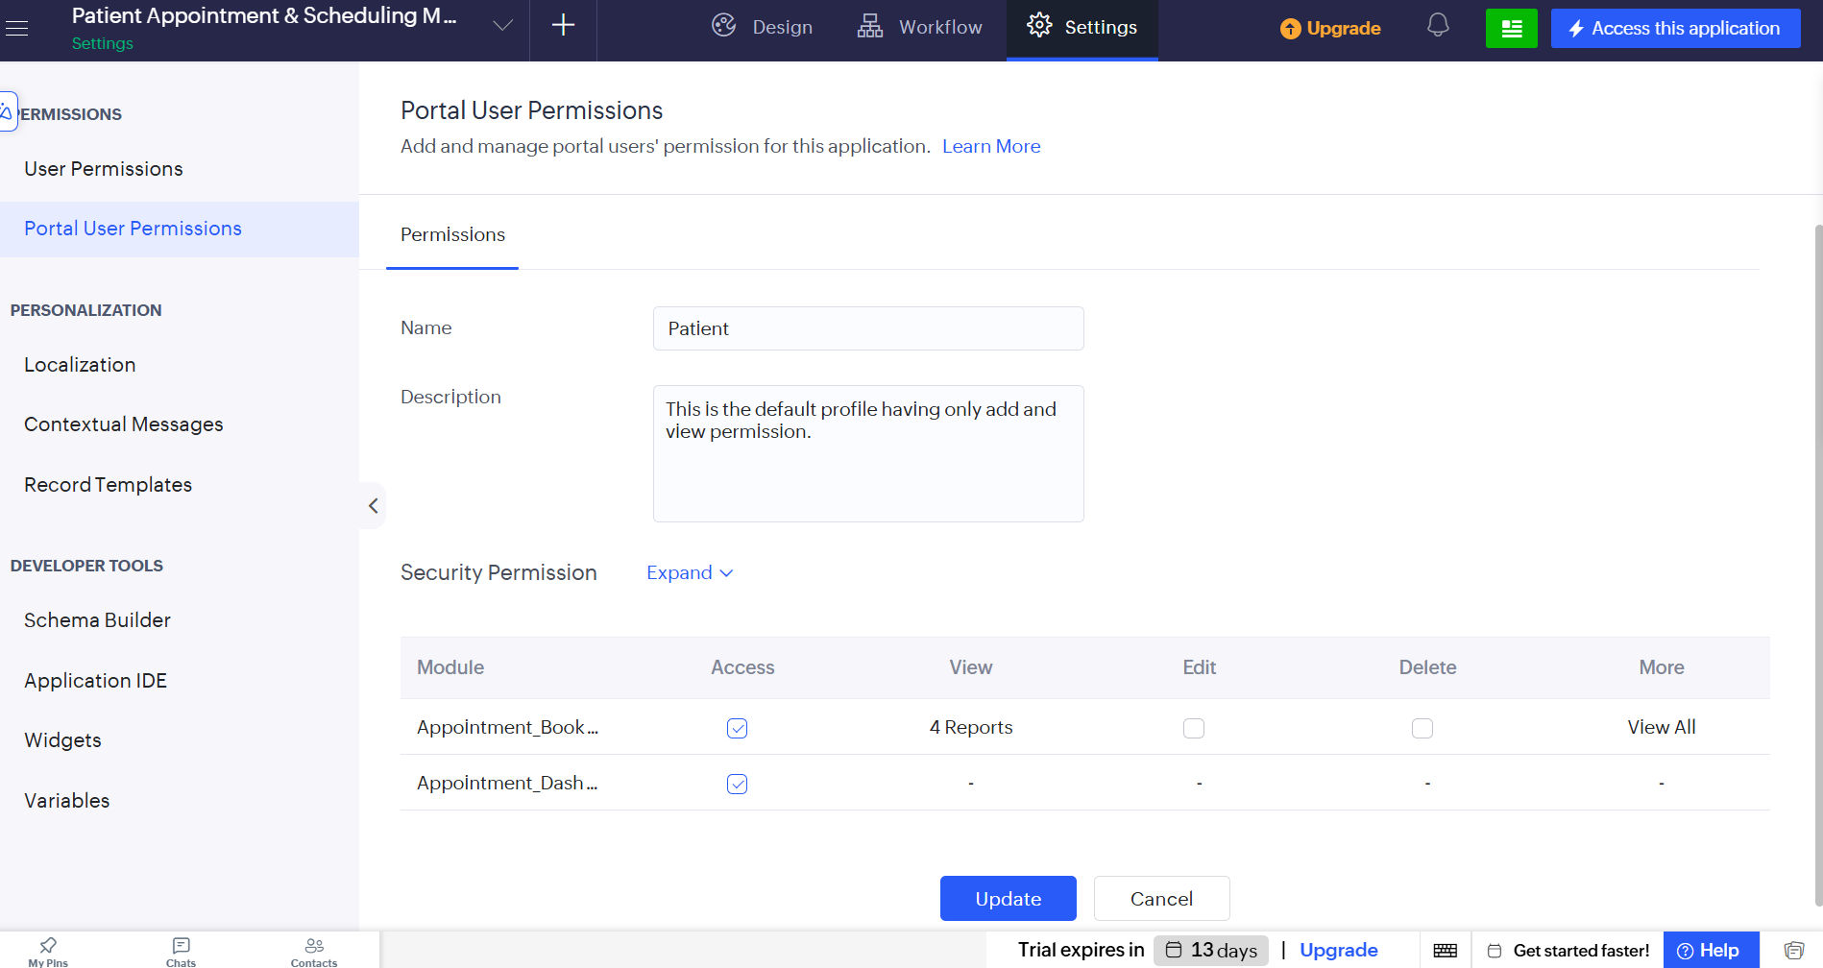
Screenshot 4 — Portal User Permissions page showing the restricted patient/customer access

Step 5: Configure Localization
1. Navigate to Settings → Personalization → Localization.
2. Enable the user/browser language option if available.
3. Save the localization settings.
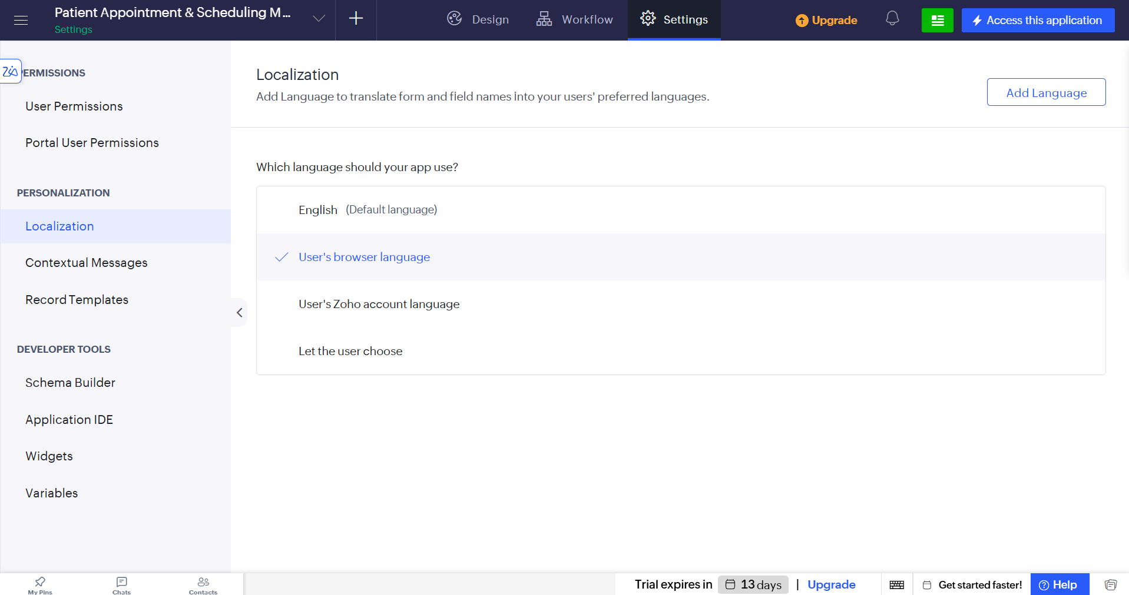
Screenshot 5 — Localization settings showing the configured language preferences

Step 6: Verify Users and Access
1. Open the Users / All Users section under user permissions.
2. Verify that the available users are listed as active.
3. Check the configured roles and permission profiles.
4. Verify that Receptionists use Receptionist_Access, Doctors use Doctor_Access, administrative users retain administrative access, and patient portal users have restricted patient-level access.
5. Confirm that the configured access follows the intended role hierarchy.
OUTPUT
The Patient Appointment & Scheduling Management application was successfully configured with role-based access control. The following were configured:
- Receptionist and Doctor roles.
- Receptionist_Access and Doctor_Access permission profiles.
- Data-sharing rules between Receptionists and Doctors.
- Restricted portal permissions for patients.
- English localization.
- User and role access verification.

RESULT
The user management and RBAC configuration was successfully completed in the Patient Appointment & Scheduling Management application. Roles, permission profiles, data-sharing rules, portal permissions, and localization were configured and saved.

